The Melbourne Literature Seminars

Homer’s Iliad

We’ll be beginning our weekly sessions on Friday 20 January, 1-3pm in Ross House 3.1 (The Jenny Florence Room). After that we’ll meet once more in 3.1 and subsequently in room 1.3.

Feel free to use any modern English translation of The Iliad. It’s always useful to have alternative versions available to us in our discussions. I’ll be using my own favourite by Robert Fagles, the details of which you can find below should you wish to locate or order a copy.
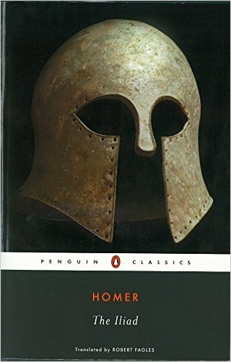
Homer, The Iliad
The rage of Achilles and much, much more. Homer’s epic helped to define the genre. Any modern translation will serve, but this by Robert Fagles is among the best: current, racy and knowing.

Penguin ISBN 13: 9780140445923

12 2-hour sessions (times TBA)
fee: $250.00

